**Lab 2 - Converting an ER diagram into Relational Schema**

In this lab, you learn how to convert an ER Diagram into a relational schema. The entire procedure is described in the following steps:

Step 1: Mapping Entity sets and Attributes

Each entity set translates into a relation. All simple/ single valued attributes of the entity set will form the attributes of the relation. Each simple attribute of the composite attributes will also form an attribute of the same relation.

Step 2: Mapping Weak Entity set

Each Weak Entity set also forms a relation. The primary key of the owner entityset will be added as a foriegn key of this relation

Step 3: Mapping 1:1 Relationship Type

**A. When one of the entity sets exhibits total participation** in the relationship, then, the relation corresponding to this entity set will include the primary key of the other entity set as a foriegn key. If there’s no total participation observed, then the primary key of one of the entity sets will be added as a foriegn key of the relation corresponding to the other entity set.

**B. When both the entity sets exhibit total participation** in the relationship, then, merge relations corresponding to both the entity sets (Note: Number of rows in both relations must be equal)

**C. Alternatively,** one can set up a new relation consisting of only the primary keys of both entity sets cross referencing each other.

Step 4: Mapping 1:N Relationships

A. Add the primary key of the relation corresponding to the entity on 1 side of the relationship to as a foriegn key to the relation corresponding to the entity on N side of the relationship

B. **Alternatively,** build a new relation consisting of primary keys of relations corresponding to both entity sets cross referencing each other

Step 5: Mapping M:N Relationships

A. Build a new relation consisting of primary keys of relations corresponding to both entity sets cross referencing each other

Step 6: Mapping Multivalued Attributes

Build a new relation consisting of the primary key of the relation with the multivalued attribute as the attributes of the relation. If the multivalued attribute is a composite attribute, all simple attributes associated with the composite attribute will appear along with the primary key of the entityset.

Step 7: Mapping N-ary relationships

Build a new relation consisting of primary keys of relations corresponding to all entity sets in the n-ary relationship cross referencing each other

**Demo Problem:**

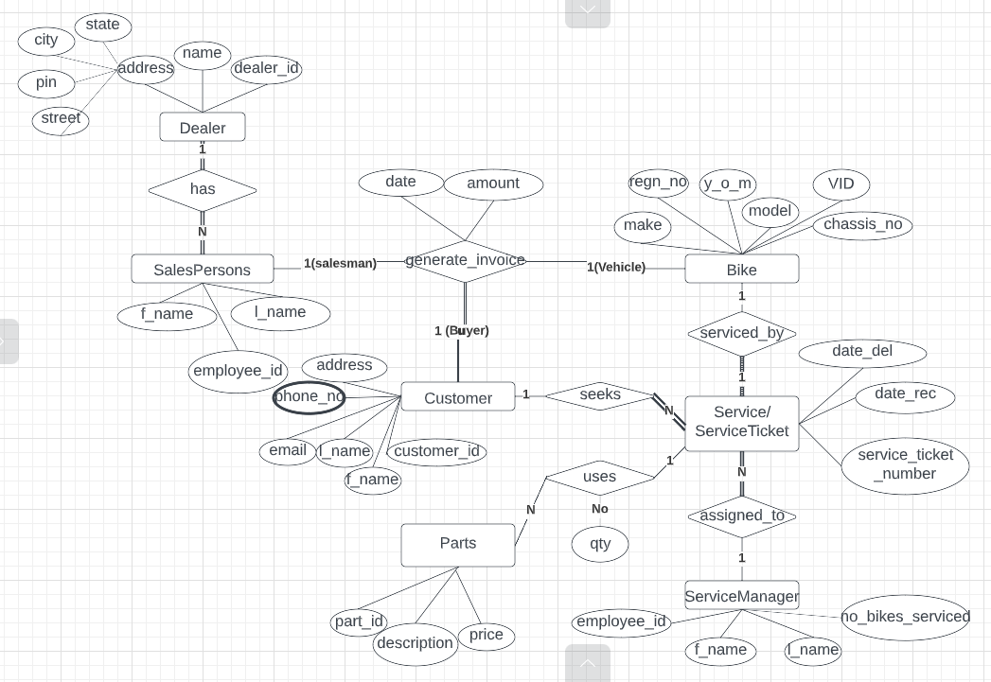

**Tools used:** Pen and Paper/ ER Tool

**Solution:**

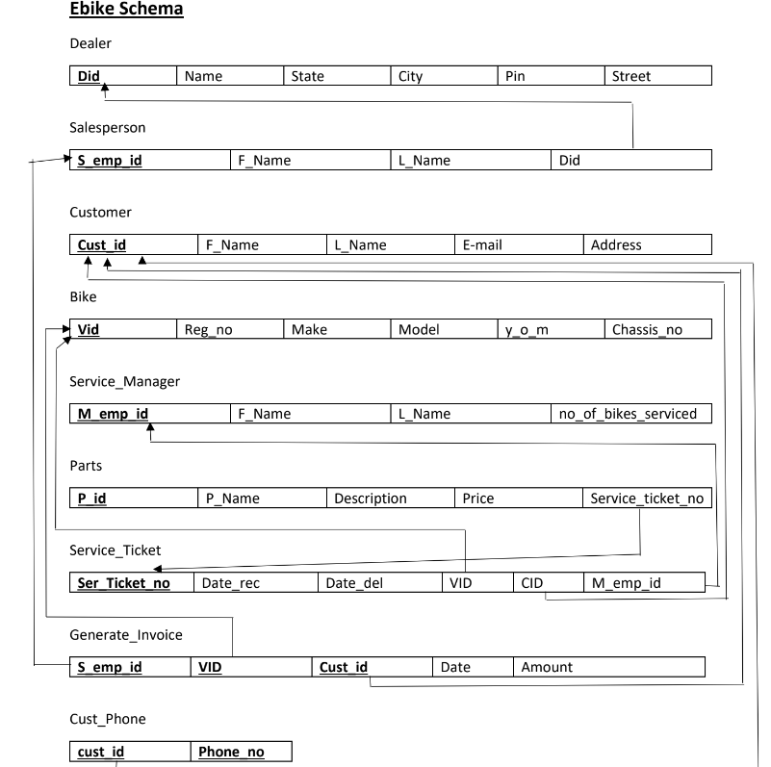

**Assignment: Railway Reservation System**

**ER Diagram:**

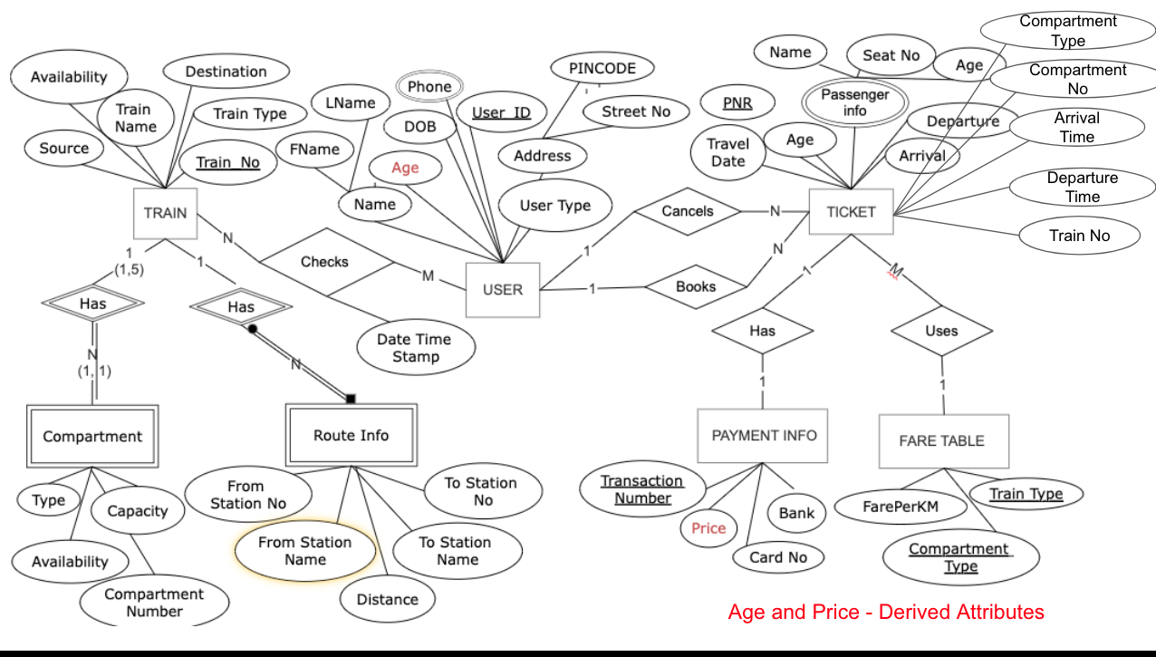

**TASK A:** Draw relational schema showing all relations identified in the above ER Diagram

**TASK B:** Mark all attributes associated with each entity

**TASK C:** Mark Primary / Composite Keys for every relation

**TASK C:** Show all foriegn key references

Take screenshots of the final picture. You may use more than one picture. Name the pictures as 1.jpg, 2.jpg etc.

Paste all .jpg files on a word file and export to pdf with name SRN_Lab2.pdf and submit the same on google form link shared with you.

